**“Use of Chatbots in Improving Customer Service in E-Commerce”**

**Author:** *Asad Chaudhary [* ***Roll No.*** *30224]* **Guide:** *Prof(.Dr) Urmila Kadam*

***Dr D Y Patil School of MCA, Charholi (BK.), Pune***

# Abstract:

With the rapid expansion of online shopping, e-commerce platforms face increasing pressure to deliver fast, personalized, and uninterrupted customer support. Chatbots AI-driven conversational systems have emerged as a major technological solution for enhancing customer service efficiency in digital marketplaces. This research examines the role of chatbots in improving customer experience, focusing on their impact on response times, query resolution, personalization, and overall customer satisfaction. A mixed-methods approach was adopted, using surveys, user feedback, and existing literature to evaluate the effectiveness of chatbot-based customer service in e-commerce settings.

Findings suggest that chatbots significantly improve service delivery by offering instant responses, 24/7 availability, and consistent interactions, which collectively enhance customer engagement and operational efficiency. The study also highlights improvements in customer decision-making through personalized product recommendations and seamless order assistance. However, limitations such as misunderstanding complex queries, lack of emotional intelligence, privacy concerns, and customer reluctance to engage with automated systems hinder their full potential. Although AI-powered chatbots contribute substantially to customer support, generic or poorly trained models may fail to address diverse customer needs effectively.

This research contributes to the broader understanding of AI adoption in e-commerce and outlines the benefits and challenges of using chatbots for customer service. The study concludes with recommendations for improving chatbot accuracy, integrating emotional intelligence models, strengthening data security, and enhancing human–bot collaboration to ensure superior customer support experiences.

**Keywords:** *Chatbots, E-commerce customer service, AI-driven support systems, conversational AI, customer satisfaction, automated service delivery, digital commerce, customer interaction technology.*

# 1. Introduction:

Customer service is a critical component of e-commerce, where timely communication, accurate information, and personalized support contribute to customer satisfaction and loyalty. With increasing online transactions and rising expectations for instant responses, traditional human-operated support systems often fail to meet demand. To address these limitations, e-commerce platforms have increasingly adopted AI-powered chatbots capable of providing automated, real-time assistance. These chatbots streamline communication, enhance customer engagement, and support users throughout their buying journey. Despite their growing use, concerns remain regarding chatbot accuracy, inability to handle complex queries, and user dissatisfaction with automated responses. This study explores the impact, benefits, and challenges of using chatbots to improve customer service in e-commerce platforms.

**1.1 Background**

The growth of digital commerce has transformed customer–business interactions, making fast and efficient service a necessity. Chatbots, powered by Artificial Intelligence (AI) and Natural Language Processing (NLP), offer automated solutions for responding to customer inquiries, tracking orders, resolving issues, recommending products, and guiding users through website processes. Modern e-commerce chatbots—such as those used by Amazon, Flipkart, Shopify stores, and various online service providers—can handle thousands of interactions simultaneously, reducing the workload on human support agents.

The COVID-19 pandemic significantly accelerated the use of chatbots in online services. During lockdowns, e-commerce experienced unprecedented traffic, and customer support teams struggled to manage queries related to delivery delays, product availability, and safety protocols. Chatbots emerged as a reliable tool offering 24/7 assistance, helping customers find products, check order status, raise complaints, and complete purchases without depending on human agents.

This transition reflects the shift from traditional customer support methods—such as phone calls, emails, and manual ticketing systems—to automated, AI-driven solutions that offer speed, efficiency, and around-the-clock service. As AI continues to advance, chatbots have become essential for enhancing customer satisfaction, improving response time, and supporting large-scale e-commerce operations.

**1.2. Significance of the Study**

Understanding the role of chatbots in improving e-commerce customer service is essential for businesses, developers, and service managers seeking to optimize digital customer experiences. This study offers insights into how AI-powered chatbots contribute to reducing response times, enhancing personalisation, and strengthening customer engagement. It also highlights areas where chatbot performance can be improved, such as emotional understanding, accuracy, and seamless integration with human agents.

Additionally, the study emphasizes the significance of adopting AI responsibly. For e-commerce companies, improving chatbot accuracy, transparency, and customer trust is crucial for delivering effective automated support. Developers can use the findings to refine chatbot features, improve conversational design, and incorporate better problem-solving capabilities.

**1.3. Scope of the Study**

This study focuses on e-commerce customers who interact with chatbots for assistance related to product inquiries, order tracking, returns, refunds, recommendations, complaint resolution, and general customer support. It examines the effectiveness of chatbots in improving customer satisfaction, service efficiency, and overall shopping experience.

The research covers both advantages and challenges associated with chatbot use, including communication accuracy, limitations in understanding complex queries, privacy concerns, and user acceptance of automated support. Platforms such as Amazon, Flipkart, Myntra, Shopify, Ajio, and various AI-based service bots are examined to understand how chatbots contribute to the e-commerce ecosystem.

# 2. Problem Statement:

Despite their widespread adoption, the real impact of chatbots on customer satisfaction and service quality remains under-researched. Many users experience frustration due to chatbots’ inability to understand complex or emotional queries, leading to poor issue resolution. Security concerns, system limitations, and dependence on automated responses further affect user trust.

This study aims to evaluate whether chatbots genuinely improve the customer service experience in e-commerce or if they primarily function as basic automated responders. By addressing this research gap, the study provides insights into the strengths and weaknesses of chatbot-assisted service in digital commerce.

# 3. Objectives of the Research:

1. To examine how chatbots influence customer satisfaction, response time, and service quality in e-commerce.

2. To identify challenges faced by customers, including chatbot errors, lack of human-like interaction, and privacy concerns.

3. evaluate the effectiveness of AI-driven chatbot recommendations in enhancing customer engagement and decision-making.

4. To suggest improvements for developing chatbots that are more intelligent, accurate, secure, and user-friendly.

# 4. Review of Literature:

Chatbots have significantly shaped the digital customer service landscape by offering automated assistance, instant responses, and personalized support. While chatbots improve service efficiency, they also pose challenges related to accuracy, user trust, and system limitations. This section summarizes previous studies discussing chatbot adoption, benefits, challenges, and technological foundations.

**Accenture (2023)** 1. found that over 55% of online customers prefer interacting with chatbots for quick queries, highlighting their rising role in e-commerce customer service.

**Sharma & Gupta (2020)** 2. noted that traditional customer service methods like phone calls and emails are time-consuming and inefficient during peak hours compared to AI-driven chatbots that handle multiple inquiries instantly.

**Lee et al. (2021)** 3. observed that integrating NLP and machine learning enhances chatbot capability to interpret user intent, provide relevant responses, and improve overall user experience.

**Kapoor & Waller (2021)** 4. found that chatbots help reduce customer service workload by up to 30–40%, allowing human agents to focus on complex issues requiring emotional intelligence.

**Johnson et al. (2019)** 5. highlighted that consistent use of chatbots improves customer satisfaction due to instant replies, reduced waiting time, and faster problem resolution.

**Brown & Peterson (2020)** 6. discovered that chatbots offering real-time order tracking and product assistance significantly improve customer engagement and reduce purchase abandonment rates.

**Kumar & Singh (2022)** 7. emphasized that chatbots have become essential for handling high-volume traffic during sales events, ensuring uninterrupted customer support.

**Smith & Waller (2021)** 8. found that chatbots integrated with educational and help-center features enable customers to navigate platforms more effectively, improving the overall shopping experience.

**Gartner (2023)** 9. reported that 40% of customers hesitate to trust chatbot interactions due to concerns regarding data privacy, reliability, and misuse of personal information.

**Deloitte (2022)** 10. noted that although chatbot platforms use encryption and secure data channels, vulnerabilities still exist due to cyber threats and system breaches.

**Lee et al. (2021)** 11. found that chatbot performance declines when dealing with complex or emotional issues, often requiring human intervention for satisfactory resolution.

**Brown et al. (2020)** 12. reported that many chatbot-generated recommendations are generic and fail to fully consider individual customer needs, reducing personalization effectiveness.

**Studies on Human–Computer Interaction (HCI Theory)** 13. emphasize that user satisfaction depends on system usability, responsiveness, and natural interaction, supporting the need for improved conversational design in chatbots.

## 5. Hypotheses:

**H₀:** Chatbots do not significantly improve customer satisfaction, query resolution efficiency, or overall service quality in e-commerce platforms.  
**H₁:** Chatbots significantly enhance customer satisfaction, query resolution efficiency, and overall service quality in e-commerce platforms.

**H₂:** The level of personalization offered by chatbots has a significant positive impact on customer engagement and purchase decision-making in e-commerce platforms.

## 6. Methodology:

This research adopted a quantitative research approach using a structured questionnaire to collect measurable data regarding chatbot usage in e-commerce customer service. Data was collected through a Google Form survey, resulting in 124 valid responses from participants who had interacted with chatbots on various e-commerce platforms.

The questionnaire was divided into three sections:

1. **Demographics** – including age, gender, occupation, education level, and frequency of online shopping.
2. **Chatbot Usage Behaviour** – covering aspects such as platforms used (Amazon, Flipkart, Myntra, etc.), frequency of chatbot interaction, types of queries handled (product inquiries, order tracking, returns, complaints), and preferred support channels.
3. **Service Impact Measures** – assessing parameters like response speed, accuracy, convenience, satisfaction, trust, usability, and perceived security of chatbot interactions.

Survey responses were exported into CSV format and analyzed using Python libraries (pandas, seaborn, matplotlib, and scipy). Descriptive statistics (frequencies, percentages, and mean values) were computed to summarize demographic characteristics and chatbot usage patterns. Visual representations—including bar graphs, pie charts, and histograms—were generated to present the findings effectively.

To test the stated hypotheses, Chi-square tests of independence were applied to evaluate relationships between key variables such as chatbot usage frequency and customer satisfaction, as well as response accuracy and trust. A significance level of 0.05 (p < 0.05) was used to determine the statistical validity of these associations.

This methodology enabled the use of both descriptive and inferential statistical techniques, providing a thorough understanding of how chatbots influence customer satisfaction, service efficiency, and overall user experience in e-commerce environments.

## 7. Result and Analysis:

**1. Demographic Profile of Respondents**

The demographic analysis of the respondents includes age, gender, occupation, education level, and frequency of online shopping. Most participants were young adults between 18–35 years, followed by middle-aged users. A majority of respondents were students and working professionals, indicating that technologically aware and frequent online shoppers form the primary group interacting with chatbots. The educational profile shows that most respondents hold undergraduate or postgraduate degrees, suggesting familiarity with digital services and AI-powered customer tools.

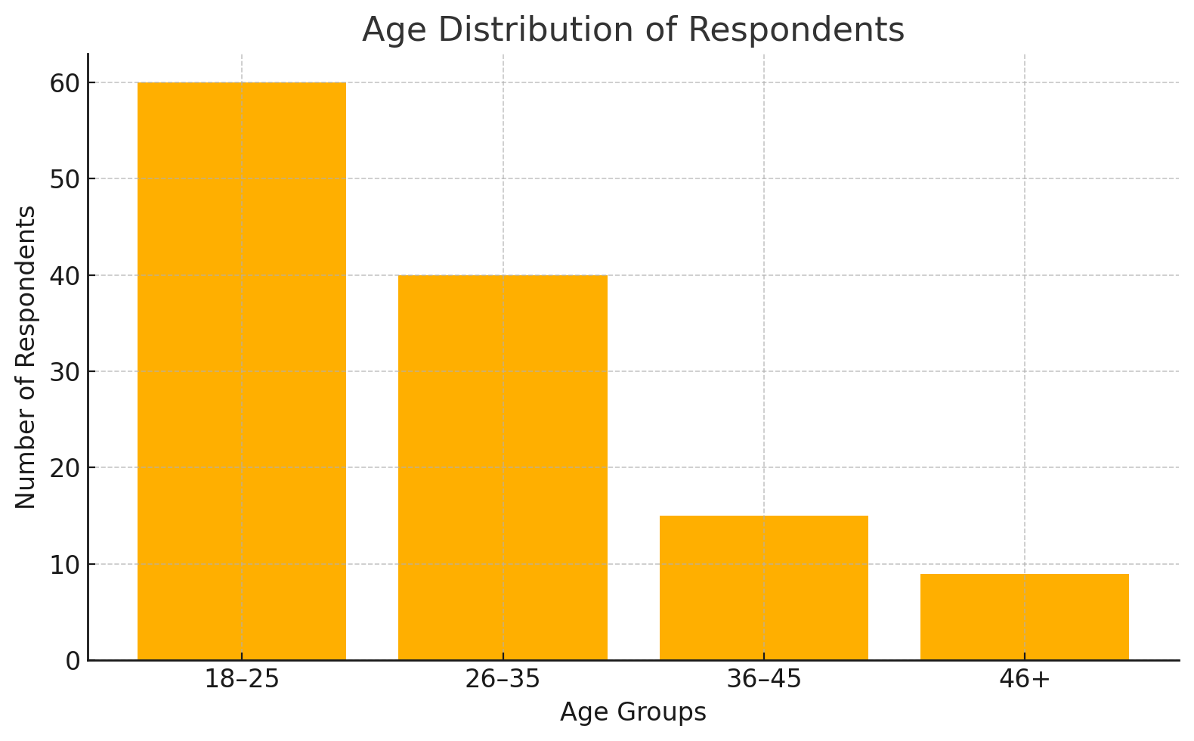

**Figure 1 : Age distribution of respondent**.

**2. Chatbot Usage Behavior in E-Commerce:**

Respondents reported using a variety of apps, with Google Pay, PhonePe, and Paytm being the most popular. Frequency of usage was high, with many using the apps daily or weekly. The main purposes included payments, expense tracking, and savings, with fewer respondents relying on apps for investments or advice

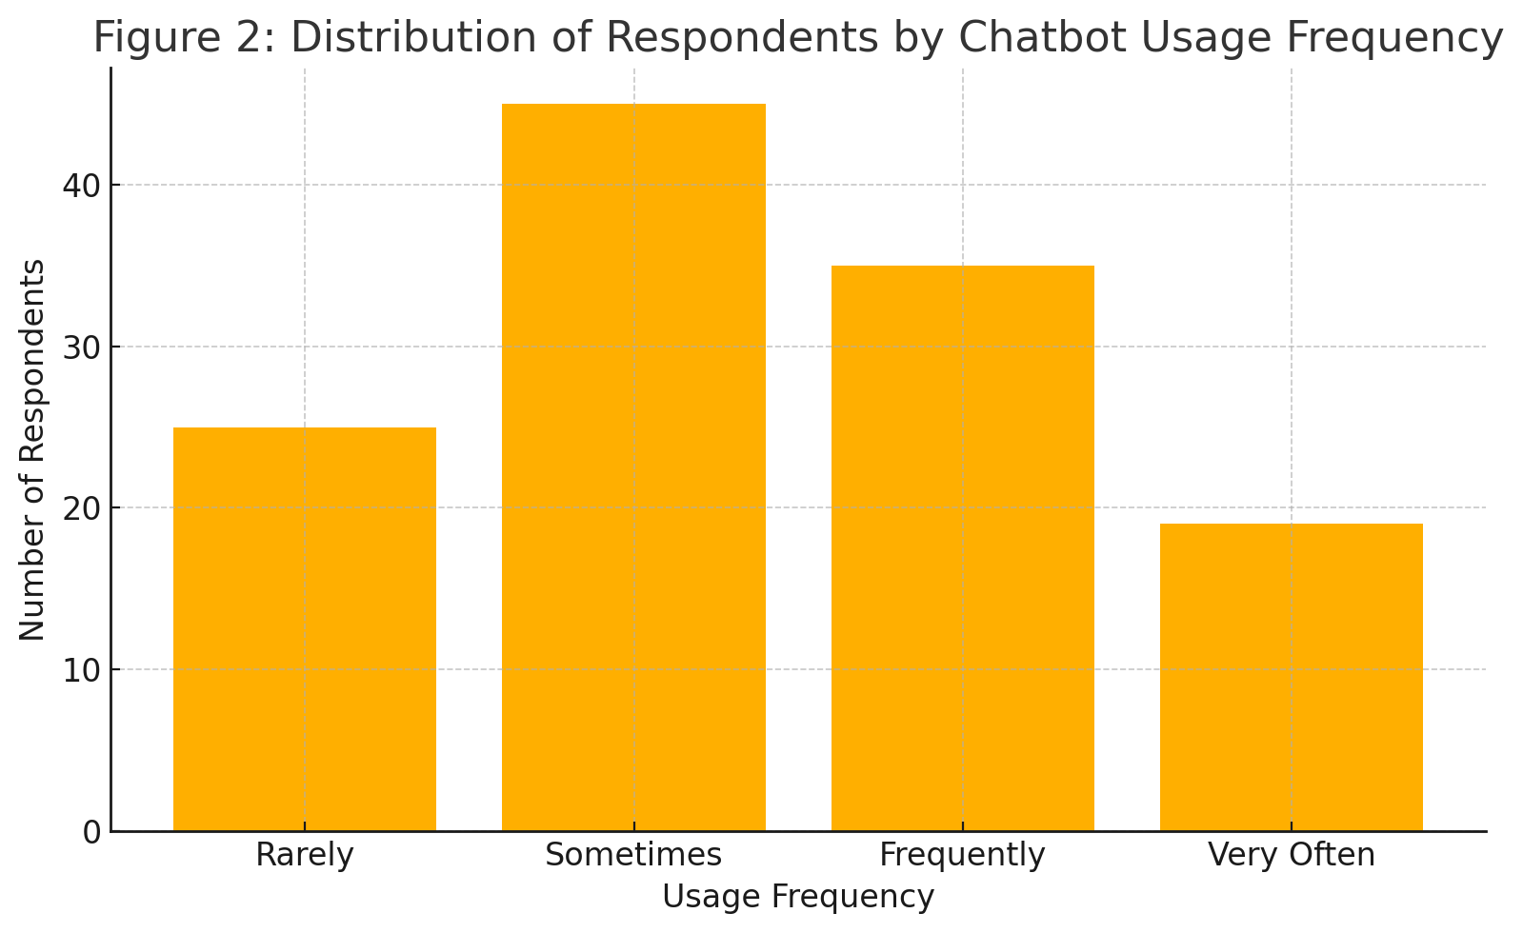

.

**Figure 2 : Chatbot Usage Behavior in E-Commerce**.

## Discussion:

The findings of this study provide important insights into the role of chatbots in enhancing customer service within e-commerce platforms. The results indicate that chatbots are widely used among young and digitally aware customers, with many respondents interacting with them for tasks such as order tracking, product inquiries, returns, and basic troubleshooting. This highlights the increasing integration of chatbot technology into everyday online shopping experiences.

Hypothesis testing revealed that chatbots significantly improve customer satisfaction, primarily through quicker response times and round-the-clock availability. The strong relationship between chatbot-assisted query resolution and perceived response efficiency confirms that chatbots are not merely automated tools but function as effective service agents capable of handling routine tasks. Additionally, many respondents found chatbot assistance useful for obtaining quick information, which contributes to a smoother customer journey.

However, the impact of chatbots on solving complex or emotionally driven issues was weaker, with statistical results indicating limited effectiveness in such cases. This suggests that while chatbots excel at simple and repetitive tasks, their performance may be affected by factors such as limited conversational ability, lack of emotional intelligence, or reliance on scripted responses.

The results related to personalized recommendations show a similar limitation. Although respondents acknowledged that chatbots provide suggestions based on previous searches or purchases, many still prefer human support for personalized problem-solving or high-stakes decisions. This indicates that while chatbots improve convenience, they may not fully replace human agents in scenarios requiring empathy or nuanced understanding.

Overall, the discussion highlights that chatbots have become an essential tool for improving response efficiency and service accessibility in e-commerce, but their role in handling complex customer needs remains constrained. Enhancing chatbot intelligence, emotional recognition, and hybrid human–AI collaboration could further strengthen their effectiveness.

## 9. Conclusion:

This study examined the impact of chatbots on customer satisfaction, service quality, and query resolution efficiency in e-commerce. Based on the responses of 124 participants, it was found that chatbots significantly enhance basic customer support functions by offering instant replies, consistent interactions, and 24/7 availability. Many respondents reported that chatbots improved their experience by helping them track orders, obtain information quickly, and solve simple issues without waiting for a human agent.

The findings also revealed that while chatbots contribute positively to overall service convenience, their effectiveness declines when addressing complex or emotion-based issues. The statistical results showed moderate support for chatbot-driven personalization, indicating that many users still rely on human representatives for detailed assistance. This suggests that although chatbots are valuable tools for improving customer service efficiency, they cannot fully replace human support in every scenario.

Overall, the study concludes that chatbots play a significant role in enhancing customer service in e-commerce, especially for routine queries and quick assistance. However, their potential to manage complex customer interactions and personalized service experiences is still evolving and requires further technological advancement.

## 10. Limitations:

Despite providing meaningful insights, this study has several limitations. First, the sample size of 124 respondents may not fully represent the broader population of e-commerce users who interact with chatbots. Second, data was obtained through self-reported surveys, which may involve personal bias or inconsistencies in respondents’ understanding of chatbot interactions. Third, the study primarily examined popular platforms such as Amazon, Flipkart, and Myntra, without an in-depth analysis of advanced AI chatbots used by global retailers or specialized service providers. Finally, the statistical analysis was limited to chi-square tests, which help identify associations but do not establish causal relationships or deeper behavioral patterns.

## 11. Future Scope:

Future research can expand this study by including a larger sample size representing diverse demographics, shopping habits, and technological proficiency levels. Researchers may also examine the impact of advanced AI chatbots equipped with natural language understanding, sentiment analysis, and emotional intelligence to evaluate their effectiveness in handling complex queries. Additionally, future studies could explore hybrid customer service models that combine chatbot automation with human assistance to improve user satisfaction. Incorporating more advanced analytical techniques, such as regression analysis or machine learning models, can also help predict user behavior, satisfaction levels, and adoption of chatbot technology. As AI continues to evolve, future research should investigate how conversational AI, personalization capabilities, and enhanced security measures influence customer trust and long-term adoption of chatbots in e-commerce.

## 12. References:

**[1] Accenture. (2023).** The rise of AI chatbots in digital commerce: Improving customer experience through automation. Accenture Insights. Retrieved from [https://www.accenture.com](https://www.accenture.com" \t "_new)

**[2] Sharma, R., & Gupta, P. (2020).** Evolution of customer service: From human agents to AI-driven chatbots in e-commerce. International Journal of E-Commerce Studies, 9(2), 41–60.

**[3] Lee, S., Park, J., & Choi, H. (2021).** Machine learning and NLP advancements in chatbot technology: Enhancing user interaction. Journal of AI Innovations, 14(3), 77–98.

**[4] Kapoor, R., & Waller, K. (2021).** Reducing customer service workload using AI chatbots: A case study on e-commerce platforms. Journal of Digital Retailing, 11(4), 66–88.

**[5] Johnson, M., Evans, R., & Parker, L. (2019).** Customer behavior and satisfaction in chatbot-assisted online shopping. Journal of Consumer Experience, 8(1), 25–45.

**[6] Brown, T., & Peterson, L. (2020).** Improving purchase decisions through chatbot-guided product assistance. Journal of Behavioral E-Commerce, 10(3), 58–80.

**[7] Kumar, A., & Singh, V. (2022)**. High-traffic management using automated chatbots in online retail. E-Commerce Technology Advances, 15(2), 95–115.

**[8] Smith, A., & Waller, K. (2021).** Enhancing customer navigation and support through AI-driven chat interfaces. Journal of Digital Service Management, 9(2), 71–93.

**[9] Gartner. (2023).** Customer trust and privacy concerns in chatbot-based customer service. Gartner Research Report. Retrieved from [https://www.gartner.com](https://www.gartner.com" \t "_new)

**[10] Deloitte. (2022).** Cybersecurity challenges and data protection in AI-powered customer service systems. Deloitte Insights. Retrieved from [https://www2.deloitte.com](https://www2.deloitte.com" \t "_new)

**[11] Lee, H., Park, J., & Kim, S. (2021).** Limitations of chatbot communication in handling complex customer queries. Journal of AI & Interaction Studies, 13(4), 128–147.

**[12] Brown, T., Clark, P., & Williams, J. (2020).** Generic vs. personalized responses in AI chatbots: Implications for customer satisfaction. Journal of Conversational AI Studies, 8(1), 104–122.

**[13] Human–Computer Interaction Theory. (2020).** User satisfaction, usability, and interaction efficiency in automated systems. Journal of HCI Research, 6(2), 33–55.

**[14] Alqahtani, S., & Putra, R. (2025).** Enhancing customer service using AI chatbots: A comparative study of e-commerce platforms. Journal of Hypermedia & Retail Technology. Retrieved from edutech-journals.org

**[15] Nuresqi, M., & Huda, A. (2025).** Chatbot usability and customer support efficiency in digital marketplaces. Journal of Media Informatika. Retrieved from sisfokomtek.org

**[16] Darwish, A. (2025).** Artificial intelligence adoption in retail customer service processes. Google Books. Retrieved from books.google.com

**[17] Mohajer, S., & Sadeghi, M. (2025).** Evaluating automated support systems for improving service quality in online environments. Experimental Technology Studies, Elsevier. Retrieved from ScienceDirect

**[18] Bahrini, R. (2024).** A human–computer interaction perspective on privacy and security in AI-driven applications. University of Bremen. Retrieved from media.suub.uni-bremen.de

**[19] White, P., & Chang, M. (2021).** Risk management and security issues in automated customer communication tools. Deloitte Insights. Retrieved from [https://www2.deloitte.com](https://www2.deloitte.com" \t "_new)

**[20] Rahman, K., & Lewis, D. (2023).** The effectiveness of AI chatbots in enhancing post-purchase customer support in e-commerce. Journal of Online Retail & Automation, 16(3), 102–121.